# BOF

Note that

* I copied the exact (close to exact) statement only for subjects IV and V.
* I thought the canonical collection is always the same and I didn't write it.

# I (4 x 0.5p)

## 1. Regular expression of the grammar:

S -> aS | a | aA

A -> bA | b

a) a+b+

b) a+b*

c) (ab)*

d) (ab)+

solution:

X = aX + b => X = a*b (1) (lectures-merged p58)

S = aS + a + aA = aS + (a + aA) =(1)> S = a*(a+aA) = a*(a + ab+) = a+(ε + b+) = a+b*

A = bA + b =(1)> A = b*b = b+

## 2. Words that belong to the grammar:

S -> 0A

A -> 1S | AA | 0

a) 00

b) 100

c) 010

d) 0100

## 3. L = { a, aa }. ? ∈ L*

a) ε

b) a

c) aaaa

d) aaa

## 4. L1 = { ε, a }, L2 = { b, c }. L1 ⊕ L2 = ?

a) ε, a, b

b) ab, bc

c) a

d) a, b, c

# II (2p) Write the RLG and RE for the following FA:



solution:

FA -> RLG:

|  | 0 | 1 |
| --- | --- | --- |
| q0 | q0 | q1 |
| q1 | q0 | q2 |
| q2 | q2 | q1 |

G = (N, Σ, P, S)

N = { q0, q1, q2 }

Σ = { 0, 1 }

P:

q0 -> 0q0 | 1q1

q1 -> 0q0 | 1q2 | 1 (add coefficient of the final state in order to be able to stop)

q2 -> 0q2 | 1q1 | 0 (add coefficient of the final state in order to be able to stop)

P, Q are regular sets over �, then

FA -> RE:

X = Xa + b => X = ba* lectures-merged page66 (1)

q0 = q00 + q10 + ε

q1 = q01 + q21

q2 = q11 + q20

q2 = q20 + q11 =(1)> **q2 = q110\***

q1 = q110*1 + q01 =(1)> **q1 = q01(10*1)\***

q0 = q00 + q01(10*1)*0 + ε

= q0(0 + 1(10*1)*0) + ε =(1)> q0 = ε(0 + 1(10*1)*0)* => **q0 = (0 + 1(10*1)*0)\***

**q1 = (0 + 1(10*1)*0)*1(10*1)\***

**q2 = (0 + 1(10*1)*0)*1(10*1)*10\***

RE is the union of the final states

since the set of final states is {q2} => RE = q2 = (0 + 1(10*1)*0)*1(10*1)*10*

# III (1p) PDA for L = { anbncm | n > 0, m >= 0 }

# IV (2p)

G = ({ S, A }, { a, (, ), ; }, P, S)

P: S -> (A) | a

A -> A;S | S

LR(0) of canonical collection of states is:

s0 = …

…

s8 = …

and FOLLOW(S) = { a, ), ; } and FOLLOW(A) = { ), ; }.

Construct the SLR table and parse the sequence w = (a;a).

# V (2p)

Define a grammar corresponding to arithmetic expressions (with operators for addition and subtraction) and then define an attribute grammar for counting the number of operators and number of operands.

Study session w/ Jinga [Copy of exam_2023-01-27_ticket-7](https://docs.google.com/document/d/1odfe8L7fgCPiIBMfxexD3GcyFHogwwsnfT8lBTV1CII/edit) [inregistrare](https://ubbcluj-my.sharepoint.com/personal/tudor_jinga_stud_ubbcluj_ro/_layouts/15/stream.aspx?id=%2Fpersonal%2Ftudor%5Fjinga%5Fstud%5Fubbcluj%5Fro%2FDocuments%2FStudy%20Sessions%2FFLCD%2Emkv&ga=1)

# my solution

grade:

1p of

2p I

0.4p II

0.8p III

0 IV

0 V

total 4.20 ( ͡° ͜ʖ ͡°)

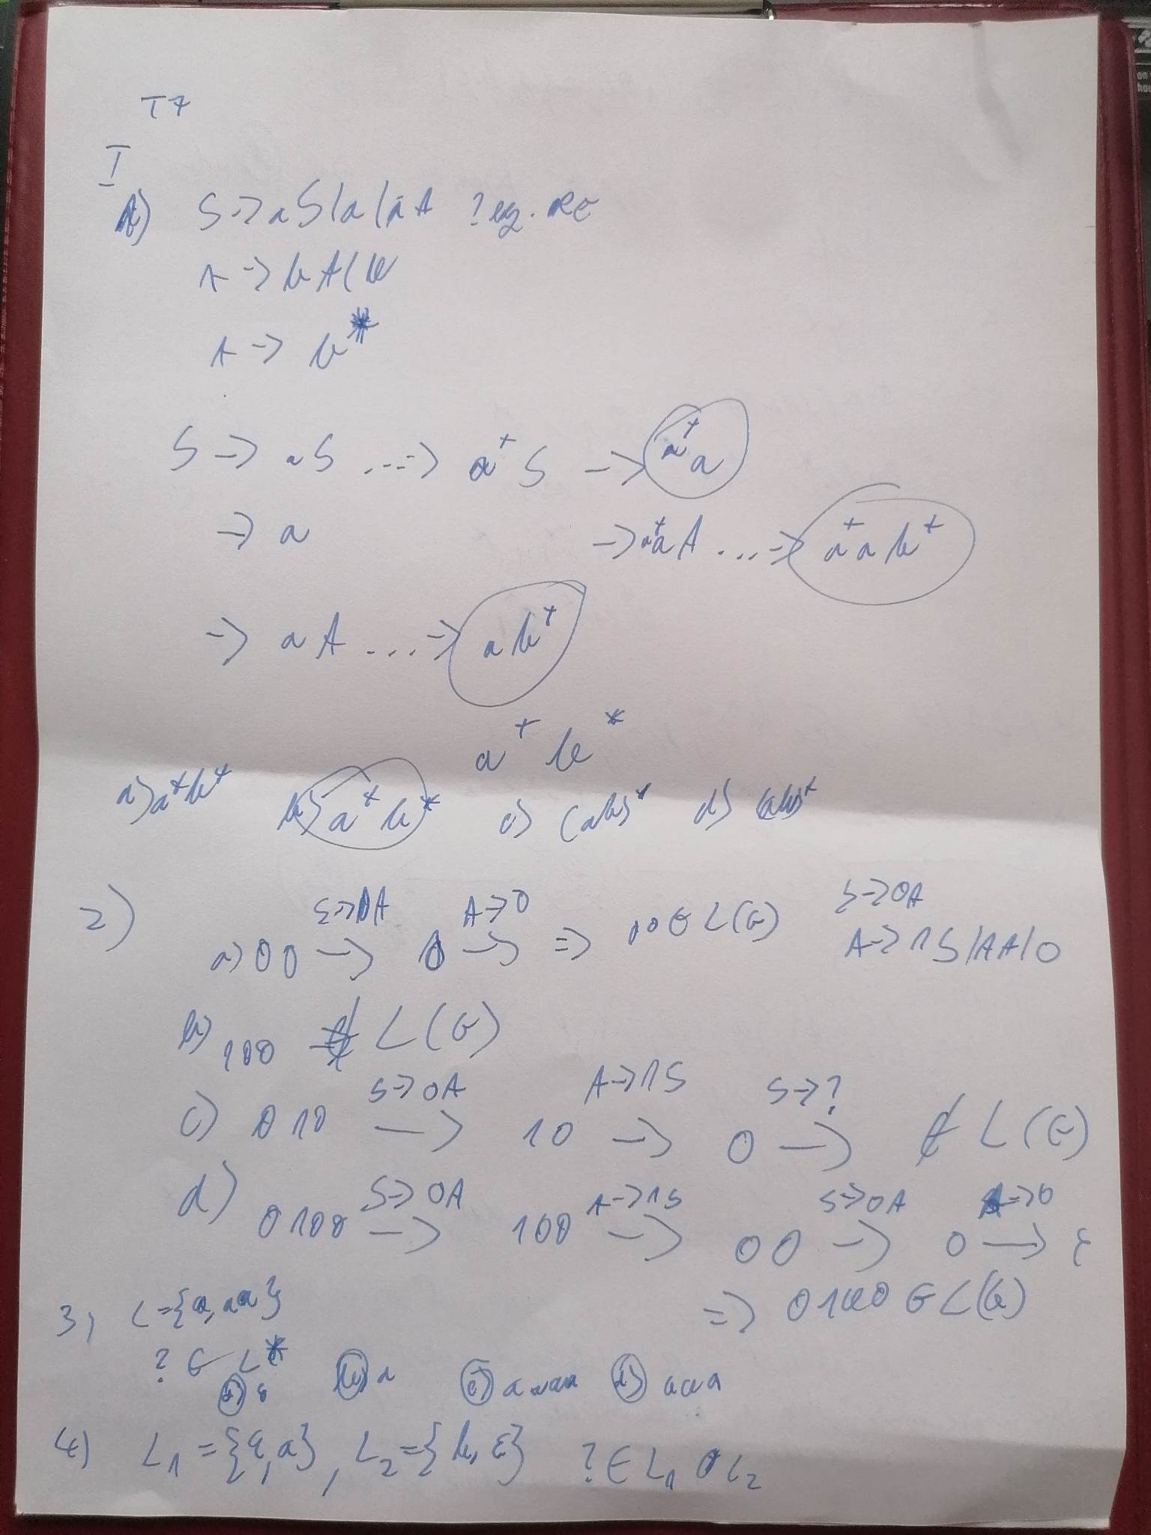

For II, if you can write directly the regex, but if it's wrong, then you get 0.

Apparently, you're supposed to transform to grammar using some equations, and then transform the grammar to regex.

For III, **+ M = (...)** means I also wrote the PDA formally. The m=0 case was missing. Either typo on the exam sheet or this 1 is wrong too.

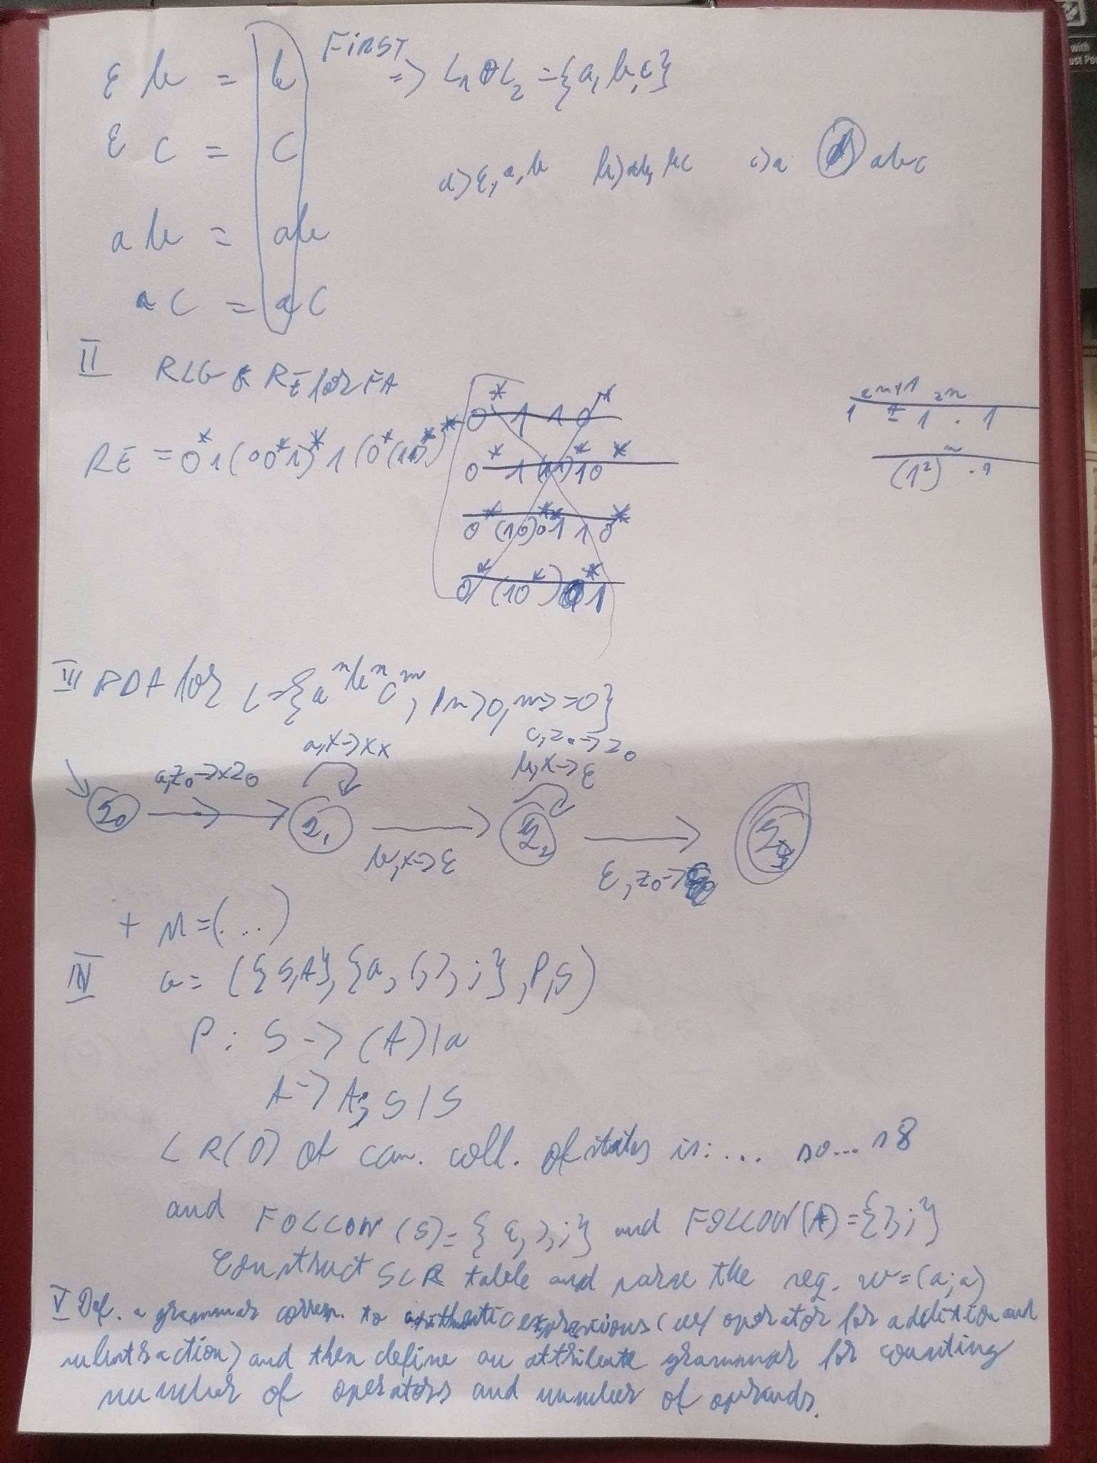

~~I think I missed an extra production: D -> 1~~

The grammar for II is wrong. At least, C and D should not be there. Actually, it's based on the regex, so it's wrong to begin with.

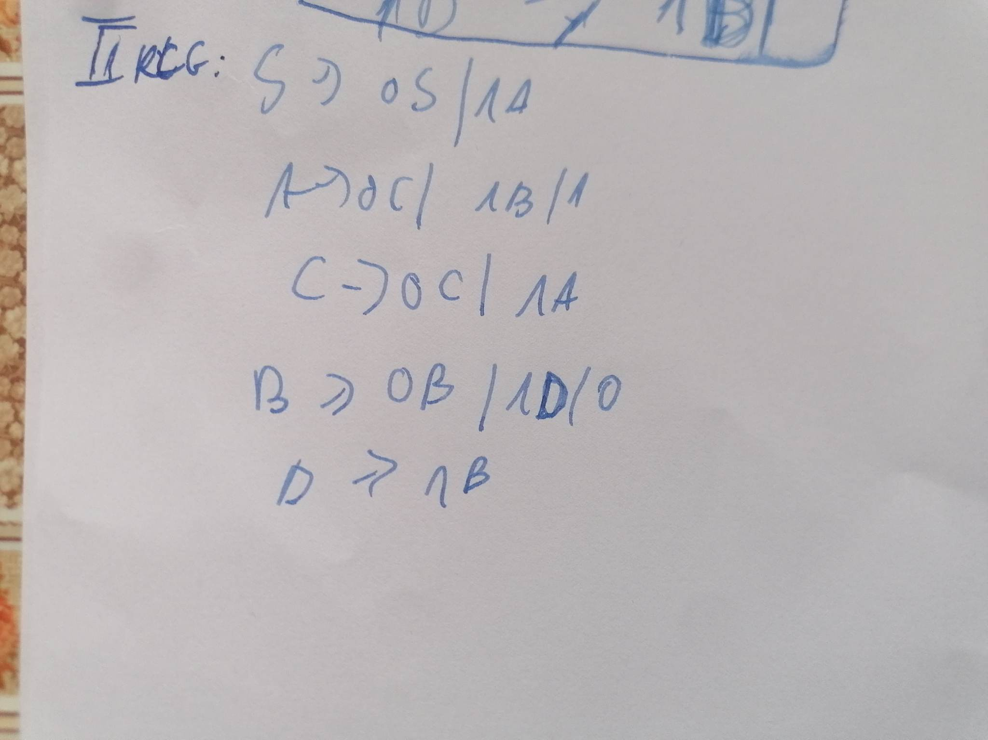

# EOF